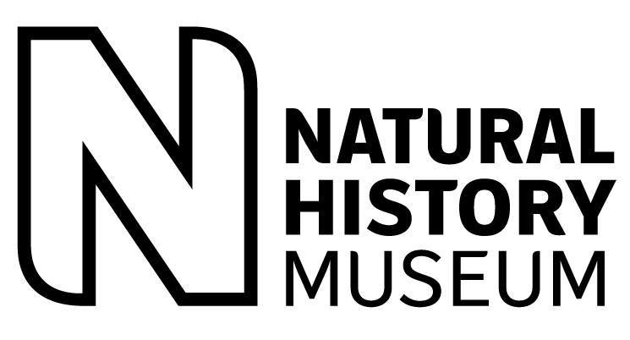

Job description and person specification
Junior Drupal Developer
Science
Entomology
Full time
36 month fixed term appointment
Science level 2
From 25,000 per annum
Closing Date: 10 September 2010
Junior Drupal Developer
We seek an up and coming junior Drupal developer for a full-time position working on the Scratchpad project (http://scratchpad.eu), which is based on the Drupal (http://drupal.org/) content management system. The role encompasses the development of content, theming and functionality for new and existing PHP and Drupal systems and applications.

Scratchpads are a platform of web-based informatics tools and services written using Drupal that allow distributed groups of biodiversity scientists to create their own virtual research communities on the Web. The successful applicant be a self starter who is proficient in theming, coding, configuring and doing quality assurance on Drupal based websites. The applicant will work as part of an agile development team working on the design and implementation of web applications, web services, data schemas and databases. Software development will be compliant with emerging Biodiversity Information Standards (TDWG, http://www.tdwg.org) and semantic web standards. Mentored training and support will be provided. The successful applicant will work with members of the developer and user community (research scientists, software developers and organisations) to manage and parse biodiversity data, in addition to helping with the design, construction and testing of Drupal modules and sites. The project includes opportunities for international travel to meetings, workshops, conferences, and presentations as a member of the Scratchpad development team.

Requirements (person specification)
Applicants must demonstrate evidence of the detailed criteria outlined below to be considered for the post.
Academic and professional qualifications
- A degree level qualification or equivalent experience

Knowledge and experience
- Previous experience in Drupal web development. We will need to see evidence of Drupal websites developed by the candidate
- Hands on experience configuring Views, CCK and other contributed Drupal modules
- Hands on experience configuring the Drupal CMS for use by non-developers to add edit to content
- Experience with PHP, MySQL, Drupal, SQL, XML, HTML and CSS
- Knowledge of jQuery/Javascript is highly desirable
- Experience with Linux is highly desirable
- Experience with Drupal 6 theming and CSS is highly desirable

Skills and competences
- Familiarity with natural history (biodiversity, taxonomy, systematics) would be useful but is not essential
- Familiarity with other scripting languages (eg Perl) in addition to PHP would be useful but not essential

Tasks and responsibilities (job description)
- Multisite Drupal site development
- Data parsing and content construction
- Development and support of Drupal Modules
- Working and supporting users in the use of their sites
- Interfacing with the user support team
Other additional information
Department: Entomology
Contract: 36 months fixed term appointment
Pay Band: Science level 2
Salary Range: from £25,000 per annum
Location: South Kensington
Hours: Full time working hours are 41 hours per week
Eligibility
This post is being advertised internally and externally. All interested parties are eligible to apply. At the Natural History Museum we value the diversity of our employees and the unique perspectives they bring to our business.
Application method
Apply online before the closing date through the NHM website: Vacancies at the Natural History Museum (www.nhm.ac.uk/jobs). Complete the online application form and provide sufficient evidence to demonstrate how knowledge skills and experience meets the detailed criteria outlined in the job description. As part of the application form candidates need to complete the following questions;

It is advisable that candidates prepare their answers to the questions in word document which can be transferred into the online application form.

- Provide specific examples from achievements, knowledge and experience or skills and competencies that demonstrate how you meet the requirements of the role which are enclosed and numbered above.
- What attracted you to the role?
- Is there anything else you wish to tell us, that you have not had the opportunity of doing elsewhere in this application form?

Candidates that wish to provide additional documents to support their application can email these to the named contact (general enquiries). Individual cover letters and CV’s will not be considered but can be used to support completed online application forms.

Closing date: 10 September 2010

Selection and appointment
Selection decisions are based on merit with candidates assessed against clear, objective criteria at each stage of the recruitment and selection process. All offers of employment made are conditional and subject to satisfactory completion of all pre-employment checks.
Contact for general enquiries
HR general enquiries: Gill Sandford 0207 942 5302, g.sandford@nhm.ac.uk
17 August 2010

